EMBEDDED INTELLIGENT MICROSCOPY SYSTEM FOR IDENTIFICATION AND COUNTING OF MICROSCOPIC MARINE ORGANISMS.
MARINE EYE AI – Portable Intelligent Plankton Detection and Counting System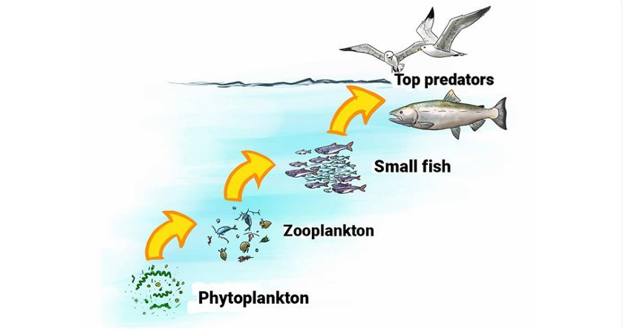

What is the solution?
Develop a compact device that accepts a seawater sample, captures microscopic images, uses AI to identify different plankton categories, automatically counts them and generates a report.
The device should work without requiring a continuous internet connection.

How will it solve the existing problems?
Existing problem | Our proposed solution
Manual counting takes time | Automatic AI counting
Requires experts | AI-assisted identification
Organisms confused with debris | Organism and debris classification
Large laboratory equipment | Compact portable microscope
Difficult to compare samples | Automatic digital records
Internet may not be available at sea | Offline AI processing
Inconsistent manual observations | Standardised image analysis

How will our proposed device work?

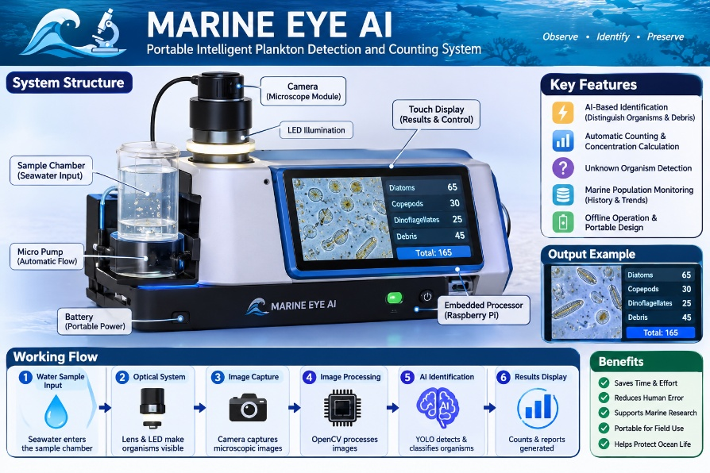
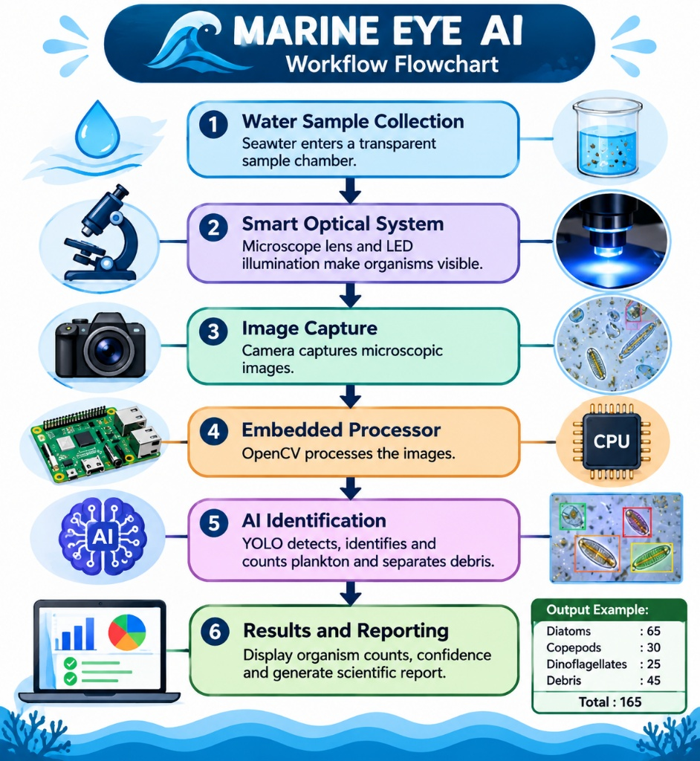

How we would make our solution different
- Smart confidence-based identification
- Sample-volume-based population measurement
- Marine health trend monitoring
- Modular, portable design
- Expert feedback and AI improvement

